Feasibility study on a self-assembled digital stethoscope for automatic detection of pneumonia in toddlers: data analysis and user perception

A. B. M. Sayeed Ud Doulah, Mirza Rasheduzzaman, Sowrav Chowdhury, Tammim Shahara Rafa, Shahriar Islam, Raidah Wasima Khan

abul.sayeed@ulab.edu.bd, mirza.rasheduzzaman@ulab.edu.bd, sowrav.chowdhury.eee@ulab.edu.bd, tammim.shahara.eee@ulab.edu.bd, shahriar.islam.eee@ulab.edu.bd, raidah.wasima.eee@ulab.edu.bd

University of Liberal Arts Bangladesh
Dhaka, Bangladesh

Summary

Pneumonia is the primary cause of death among children under the age of five. China (with 21 million instances), Pakistan (with 10 million cases), India (with 43 million cases), and Bangladesh are, in order, the countries with the highest case totals (1.87 million). About one-fifth (19%) of all child fatalities are caused by pneumonia, and sub-Saharan Africa and Southeast Asia account for more than 70% of these cases combined. In a previous work, we developed a self-assembled digital-stethoscope to acquire high-quality precise lungs sounds. Multiple time and frequency domain features were obtained from raw data and critically analyzed from the developed device. The purpose of this work is to perform a feasibility study of the portable, low-cost digital stethoscope for recording auscultation of lung sounds from healthy and children with different stages of pneumonia. The collected data will be stored in SD card and analyzed for automatic detection of pneumonia utilizing machine learning algorithm. It is expected that the study will provide high-quality lung sounds and will be helpful to develop automatic pneumonia detection model. In addition to the feasibility study, this work will be able to create a large-scale database of respiratory sounds with pneumonia.

Impacts of this project

- Many rural areas around Bangladesh lacks the access to specialist and often diagnosis of detection goes undetected, leading to life-threatening conditions.
- The developed device has key features such as the filtration of heart sounds and other environmental noises, amplifying the weak signals, store and transmit them.
- A feasibility study utilizing the device may lead to automated machine learning model that can predict the pneumonia at its early stage.
- In comparison to commercially available digital stethoscopes, the price of the whole system is another significant effect of this research.
- A database of high-quality precise lung sounds can be used to develop a potential machine-learning algorithm to predict pneumonia and other lung diseases.

I. Introduction

Pneumonia is the greatest infectious illness cause of death in children under the age of five worldwide [1], accounting for an estimated 800,000 fatalities annually, of which more than half occur in only five low- and middle-income countries (LMIC) [1,2]. In 2015, the projected yearly incidence of pneumonia in children under the age of five in developing countries was 231 episodes per 1,000 children, resulting in about 138 million clinical pneumonia episodes in this age group [3]. Recognizing a child's sickness and obtaining treatment as soon as possible is crucial for lowering child mortality due to pneumonia [4]. Conventional auscultation with an analog stethoscope requires a quiet environment and a cooperative patient, which is troublesome in hospitals/clinics, especially in LMICs where patient numbers often exceed capacity. Exam rooms are generally full with chatting individuals, ringing phones, and whirling fans; the child being examined may be nervous, rebellious, or crying. To improve hearing, digital stethoscopes decrease ambient noise [5, 6] Conventional auscultation with a stethoscope has limits owing to the human auditory system, which ranges from 20 Hz to 20 kHz in youth and decreases beyond middle age. Digital stethoscopes may magnify sounds 100 times [7]. When interpreting body sounds, inter-rater variability is high, regardless of the amount of expertise of the practitioner. Modern advances in ML and AI have allowed the efficient analysis of complicated data, such as lung sounds and rhythms. In [8], Machine Learning achieved >90% illness diagnostic accuracy. These research [9-11] use machine learning and AI to detect lung disorders.

In a previous work [12], three conventional acoustic stethoscopes were transformed to equip a transducer (condenser microphone) in the tube. The digital signals from the transducer are stored and processed to extract certain features. The extracted features are assessed and compared by using the Pearson correlation coefficient (P≤0.05), to found out that an MDF Acoustica Stethoscope available in local market has the potential to record high quality data to develop a potential machine learning algorithm.

This work focuses to do a feasibility study of collecting a large number of high-quality lungs sounds of both healthy and unhealthy subjects from infants and toddlers with pneumonia.

II. Literature Review

Using distal stethoscopes with AI for respiratory analysis has been studied. CNN may distinguish chronic, non-chronic, and healthy groups by monitoring respiratory sounds, according to a research. CNN may subcategorize disorders such as COPD, bronchiectasis, pneumonia, and bronchiolitis [13]. The suggested approach will help physicians categorize disorders. This study uses COPD and pneumonia patients' lung sounds (LS) from ICBHI and self-collected datasets. EMD, DWT, and ANOVA are used to segment, remove noise, and pick features. ADASYN sampling eliminates class imbalance. FG-SVM distinguishes between COPD, pneumonia, and healthy persons based on lung sounds. This machine learning model runs on a Raspberry pi 3 model B+ (Cortex-A53 (ARMv8) 64-bit SoC @ 1.4 GHz) using a hardware-compatible language. The device can properly test for COPD and pneumonia [14]. Without blood tests, chest X-rays, or pulse oximetry, pneumonia may be diagnosed using a digital stethoscope. Several simulations use SVM and KNN to test the proposed strategy's accuracy. MLP had 91.6% accuracy and CNN 86%. Gradient boosting improved pneumonia patient recognition by 97%. Future versions of this technology will interact directly with digital stethoscopes to anticipate pneumonia diagnosis. Pneumonia will be diagnosed promptly. Digital stethoscope lung sound analysis may assist predict Covid-affected lungs. The proposed approach anticipates pneumonia better than any other algorithm while being quicker, safer, and more cost-effective. [15]

III. Methodology

Hardware

Raspberry Pi computers were created in 2009 by the Raspberry Pi Foundation with the initial intention of educating students [16]. This compact single-board computer (about the size of a credit card) is comprised of system-on-a-chip technology, including a quad-core ARM processor (ARM Holdings), 1 GB of memory, and a graphics processing unit. Wi-Fi, Bluetooth, Ethernet, and more modules are likewise included inside the PCs.
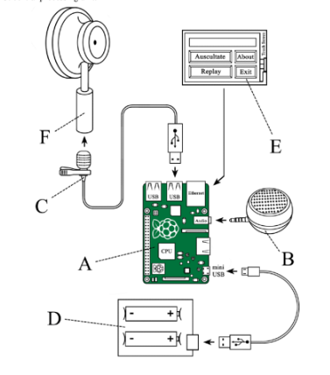
The operating system on the Raspberry Pi will be installed and activated and then connected the components listed in Figure 1. Raspberry Pi may possibly capture data from any form of sensor and transmit it to the software application. We utilized a standard USB collar microphone as a transducer from a modified stethoscope chest piece to capture sound wave impulses and convert them to electrical signals through USB connection. The Python-based application (Auscul Pi Console) then received and processed the digital data before sending it back to the micro speaker. The connections between each component and the Raspberry Pi computer are shown in Figure 1.
Figure 1 Schematic of the connections (A)Raspberry Pi 3 Model B+. (B) Speaker. (C) USB Microphone. (D) Rechargeable batteries (18650). (E) 3.5-inch touch screen. (F) Chest piece of stethoscope
Data Storage and Transmission

We will be using Python as it is one of the most popular programming languages [17] because of its simplicity, outstanding readability, and extensive functionality, and because third-party specialists from varied industries utilize it to produce new packages and modules [18]. Python may combine packages and modules to create code with desired functionalities. The PyAudio package processes audio [19]. It's available on GitHub [20]. Auscul Pi Console can run on Raspberry Pi with tkinter's GUI [site the paper]. The application creates a Waveform Audio File Format (.wav) and digital NumPy array file (.npy) [21] with the measurement date and time.

Protocol

The main goal of this study is to collect data from a total of 50 healthy toddlers and pneumonia patients. We will collect data from recognized institutions with the full consent of patients and approval of the physician in-charge. For the collection of data, we will be following the National Research Ethics Committee (NREC) and IEEE Data Access and Use Policy. Since our point of interest are with infants around the age of 0-3 years, a form of approval (consent form) with full description of the procedure will be obtained from healthy/patient’s parents. The brief protocol of the feasibility study is shown in Figure 2.
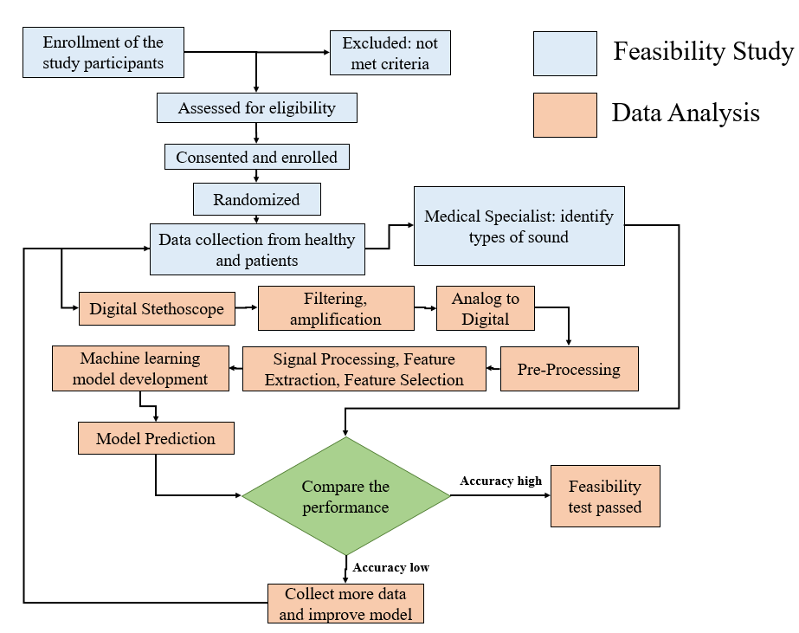
Figure 2 Flow diagram of the proposed feasibility study
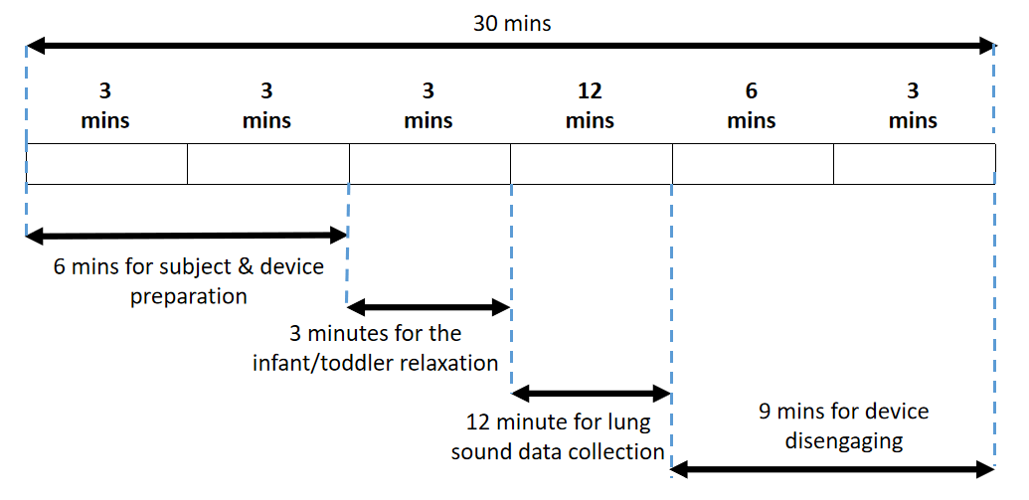

Figure 3 Time Frame for Single Participant Data Collection

The stethoscope bell will be placed in the multiple spots to record tracheal, bronchial, bronchovesicular, and vesicular regions. As reported in [22], the auscultation will be done in around 12 minutes’ time. A tentative time frame for single participant data collection is given in Figure 3.

III. Time Line

IV. Budget

A budget estimate for the completion of the project is provided below:

Sl. | Name | Price (tk) | Quantity | Total Price (tk)
1 | Raspberry Pi 3 Model B+ | 5,000 | 5 | 25,000
2 | Boya BY-M1 Pro 3.5mm Lavalier Microphone | 2,000 | 5 | 10,000
3 | 3.5inch Resistive Touch Display (B) for Raspberry Pi | 4,000 | 5 | 20,000
4 | 3.7V 18650 Rechargeable Battery 2600mAH True Capacity | 500 | 20 | 10,000
5 | Battery Charger | 300 | 5 | 1,500
6 | MDF Acoustica Stethoscope | 2000 | 5 | 10,000
7 | 3D Printed Case | 1500 | 5 | 7,500
8 | Honorarium / Subject Fee | 3,000 | 50 | 150,000
9 | Facilitators of the subject / Health Workers | 1,000 | 15 | 15,000
10 | Data storage | 10,000 | 2 | 20,000
11 | Research Assistant (for 6 months) | 20,000 | 1 | 120,000
Total |  |  |  | 389,550

V. Conclusion

The goal of this project is to collect data from a large number of healthy and unhealthy subjects, to perform the feasibility study of this project we initially perform this on 50 subjects. We will collect the data to develop a database and build a machine-learning algorithm. In future this work can potentially be extended by other researchers and have national database of lung sounds.

References

1. Every child’s right to survive: A 2020 agenda to end pneumonia deaths. 2020. Available: https://www.unicef.org/media/64701/file/Every-childs-right-to-survive-pneumonia-2020.pdf. Accessed: 2 November 2021.
2. UNICEF. Save the Children. Fighting for Breath Call to Action: End childhood pneumonia deaths. 2018. Available: https://www.savethechildren.org.uk/content/dam/gb/reports/policy/fighting-for-breath-call-to-action.pdf. Accessed: 2 November 2021.
3. McAllister DA, Liu L, Shi T, Chu Y, Reed C, Burrows J, et al.Global, regional, and national estimates of pneumonia morbidity and mortality in children younger than 5 years between 2000 and 2015: a systematic analysis. Lancet Glob Health. 2019;7:e47-57. 10.1016/S2214-109X(18)30408-X [PMC free article] [PubMed] [CrossRef] [Google Scholar]
4. Wardlaw TM, Johansson EW, Hodge MJ. Pneumonia: the forgotten killer of children: New York: UNICEF; 2006. [Google Scholar]
5. Kevat AC, Kalirajah A, Roseby R. Digital stethoscopes compared to standard auscultation for detecting abnormal paediatric breath sounds. Eur J Pediatr 2017;176:989–92.
6. Thinklabs. Thinklabs one digital stethoscope. Centennial, CO, USA: Thinklabs, 2015. https://www.thinklabs.com/
7. D. Bardou, K. Zhang and S. Ahmad, "Lung sounds classification using convolutional neural networks", Artificial Intelligence in Medicine, vol. 88, pp. 58-69, 2018. Available: 10.1016/j.artmed.2018.04.008.

8. N. Das, M. Topalovic and W. Janssens, "Artificial intelligence in diagnosis of obstructive lung disease", Current Opinion in Pulmonary Medicine, vol. 24, no. 2, pp. 117-123, 2018. Available: 10.1097/mcp.0000000000000459.

9. A. Kevat, A. Kalirajah and R. Roseby, "Artificial intelligence accuracy in detecting pathological breath sounds in children using digital stethoscopes", Respiratory Research, vol. 21, no. 1, 2020. Available: 10.1186/s12931-020-01523-9.

10. H. Mukherjee et al., "Automatic Lung Health Screening Using Respiratory Sounds", Journal of Medical Systems, vol. 45, no. 2, 2021. Available: 10.1007/s10916-020-01681-9.

11. S. Chowdhury, A. B. M. S. U. Doulah and M. Rasheduzzaman, "Quality Assessment of Respiratory Sounds Extracted from Self-Assembled Digital Stethoscopes," 2022 International Conference on Advancement in Electrical and Electronic Engineering (ICAEEE), 2022, pp. 1-6, doi: 10.1109/ICAEEE54957.2022.9836502.

12. Grzywalski T, et al. Practical implementation of artificial intelligence algorithms in pulmonary auscultation examination. Eur J Pediatr. 2019;178(6):883–90.
Article PubMed PubMed Central Google Scholar

13. Kevat A, Kalirajah A, Roseby R. Artificial intelligence accuracy in detecting pathological breath sounds in children using digital stethoscopes. Respir Res. 2020;21(1):253.
Article PubMed PubMed Central Google Scholar

14. S. Z. Hassan Naqvi and M. A. Choudhry, “Embedded system design for classification of COPD and pneumonia patients by Lung sound analysis,” Biomedical Engineering / Biomedizinische Technik, vol. 67, no. 3, pp. 201–218, 2022.

15. B. Vidhya, AI Based Diagnosis of Pneumonia Springer Science+Business Media, LLC, part of Springer Nature 2022. Wireless Personal Communications (2022) 126:3677–3692 https://doi.org/10.1007/s11277-022-09885-7

16. Upton E. Ten millionth Raspberry Pi, and a new kit. Raspberry Pi Blog. 2016 Sep 08. URL: https://www.raspberrypi.org/
blog/ten-millionth-raspberry-pi-new-kit/ [accessed 2022-06-23]

17. Van Rossum G, Drake F. Python 3 Reference Manual. Scotts Valley, CA: CreateSpace; 2009.

18. Python Package Index. URL: http://pypi.org [accessed 2022-05-16]

19. Pham H. PyAudio 0.2.11. Python Package Index. 2006. URL: https://pypi.org/project/PyAudio/ [accessed 2022-05-15]

20. Audio Spectrum Analyzer in Python. GitHub. URL: https://github.com/markjay4k/Audio-Spectrum-Analyzer-in-Python
[accessed 2022-05-16]

21. Oliphant TE. A guide to NumPy. US: Trelgol Publishing; 2006.

22. M. Sarkar, I. Madabhavi, N. Niranjan and M. Dogra, "Auscultation of the respiratory system", Annals of Thoracic Medicine, vol. 10, no. 3, p. 158, 2015. Available: 10.4103/1817-1737.160831.

